

September 4, 2018

(Disciples of Christ)

First Christian Church

FCC’s Vision Statement:

***First Christian Church seeks to be a family of disciples, growing with God’s grace and serving with others in faith, hope and love.***

*As I laid my head down on the pillow Sunday evening, the word AWESOME just kept running through my mind! What an AWESOME God we have! The Spirit of worship, the gathering for the 150th anniversary meal, the celebration of Raymond’s Kids Saturday, and the wonderful volunteers who cooked, set up, promoted, and worked behind the scenes were all just AWESOME! What a way to kick off a ministry and celebrate our 150 year history!*

*Then I began to think about that word AWESOME. Merriam-Webster dictionary defines it as “inspiring Awe”. Isn’t that right? After what we experienced this weekend at First Christian Church, I have had several emails, texts, phone calls and face to face conversations with people who were present. Each one of them have said how much in AWE of God they were in one sense or another. Isn’t that what we are called to do, stand in awe of our wonderful Creator! The One who wants nothing more than to be intimate with each and every one of us! I pray this week you walk closely and feel the loving presence of God with you. It will leave you feeling AWESOME!*

*And the exciting news is that we are not through celebrating our 150th Anniversary! There are several events planned that I am sure will be just as AWESOME as Sunday was. I have included them below. Please mark your calendars and let’s keep the wave of blessing flowing!*

1. *Grammy Award Winning Blackwood Brothers Gospel Quartet coming on Sunday night*

*October 14th*

1. *Dale Hansen, Channel 8 Sports Director, coming Thursday night October 18th for Make A*

*Positive Difference Night for All Area Varsity Athletes and Coaches*

1. *Saturday Night November 3rd, we are having spirited Jarvis Christian Choir from Jarvis*

*Christian College in Hawkins, Texas*

*I know God is alive and well here at FCC Paris! There are many Awesome days ahead for us. I invite you to come on the journey with us. It is exciting to see God at work among his people! See Ya Sunday and BRING A FRIEND!*

*Barry*

Everett McAulay

Accompanist

Rev. Barry A. Loving

Minister

**Kindness Quote***“Every time I wonder who I should love and for how long I should love them, God continues to whisper to me: Everybody Always.” Bob Goff*

Tonya Earley  
Administrative Assistant  
903-785-5516  
office@firstchristianparis.com

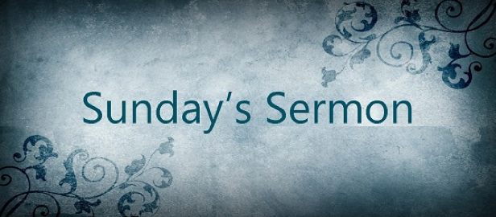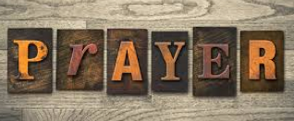

**Wednesday, September 5  
9am – Men’s Coffee**

**2pm – Hope Team**

**Sunday, September 9th**

**9:50am – Sunday School**

**10:50am – Worship   
12pm – Elders Meeting  
  
Monday, September 10**

**6pm-- Nar ANON**

**6:30pm – Emmaus Group**

**Tuesday, September 11**

**10:30am-Lunch and Learn**

**Wednesday, September 12**

**9:00am – Men’s Coffee**

**12pm—Al--ANON**

**2:00pm – Hope Team**

**Thursday, August 16   
6pm – Al--NON**

**SERVING IN WORSHIP SEPTEMBER 9TH,2018**

Elders:  Jerry Lane, Don Wilson

Homebound Communion:  The Harrisons

Deacons:  Bob Guymon, Harrel Harrison, Carolyn Lane, Vickie Perry

Lay Reader: Annette Caviness

 Communion Prep:  Bob Guymon

Greeters:  The Seekers class

Sound Tech:  Donald Krayniak

Outreach Committee will be collecting $10.00 gift cards from Wal-Mart, Kroger or Brookshires to have for the minister and office to use during the Thanksgiving and Christmas season for helping persons in need in our community that come by or call our Church for immediate food or gas. Please bring and drop in the offering plate through the month of October.

**Scripture: Mark 7:24-37  
Sermon: No Secrets Here**

**Meal Sharing** – We are gearing up for our second round of the Traveling Tablecloths. If you didn’t sign up for the first round, be watching for your chance to join in the fun!

**Community Connections** – Our outreach board in the foyer highlights various ways YOU serve the community. The display will rotate regularly. If your group is not represented, please let the office know so we can add it to the display.

**Sharing Facilities** – Several ideas have been shared for ways to increase our facility use including: basketball goal, volleyball net, community garden, labyrinth, dog park and a walking trail. What would you like to see? Share your ideas with the Hope Team.

**Hope 150 Weekly Update**

**Ripples are starting… waves are coming!**

Robyn Jackson, Sue McAulay, Jean Campbell, Gerald Hutchings, Eulice Howell, Charin Clayton, Robbie and LV Morrow, Tony Guymon, Karen Lodes, Randi Haggard, Travis Coston, Bob Guymon, Dick Towers, Jerry Lane, Ruth Lee

In Touch Newsletter

September 4, 2018